National Holidays 假期 jià​qī​ in the U.S.
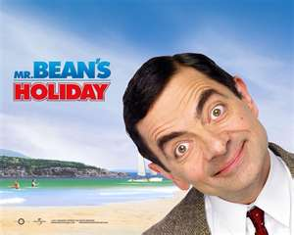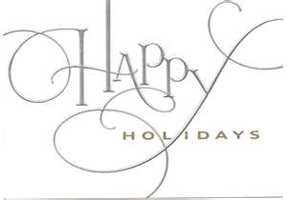
New Year’s Day - January 1 – The celebration (庆祝会 qìng​zhù​huì​) starts the night before on New Year’s Eve (除夕 chú​xī​) with fireworks (烟火 yān​huǒ)​. Usually people have a big family dinner on New Year’s Day.

Martin Luther King Day – Third (第三dì​sān) Monday in January - Dr. King was an African American (黑人 hēi​rén)​ civil rights (公民权利 gōng​mín​quán​lì​) leader (领导 lǐng​dǎo​) in the U.S. and was born on January 15th 1929.

President’s (总统 zǒng​tǒng​) Day – Third (第三 dì​sān​) Monday in February – President Washington’s (华盛顿) birthday was February 22nd, and Abraham Lincoln’s (林肯) birthday was February 12. Washington was the first (第一 dì​yī​) President of the United States and Abraham Lincoln started the civil war (内战 nèi​zhàn​ 1861-1865) that ended slavery (奴隶制 nú​lì​zhì​) in the United States.

Memorial Day – Last Monday in May – Honors (尊重 zūn​zhòng​) men and women who died (死 sǐ​) in American wars (战争 zhàn​zhēng​). Beginning of summer season in the USA.

Independence day (July 4th) – Celebrates (庆祝) the Declaration of Independence (独立宣言 dú​lì​xuān​yán​) from England, and the starting of a new country: the USA in 1776.

Labor Day – First Monday in September – Celebration for workers (工人 gōng​rén) ​ –
End (最后 zuì​hòu​) of the summer season.

Thanksgiving Day – Fourth Thursday in November - Celebrates giving thanks for autumn harvest (收获 shōu​huò​). Usually families have a turkey (火鸡 huǒ​jī​) dinner.

Christmas Day – December 25th – Christian (基督徒 Jī​dū​tú​ ) holiday that celebrates the birthday of Jesus (耶稣 Yē​sū​) in the year zero. Holiday starts on Christmas Eve December 24th.
American HOLIDAY VOCAUBLARY
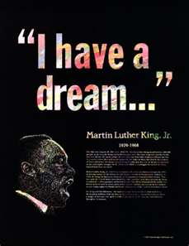Dream: 梦想 mèng​xiǎng​ 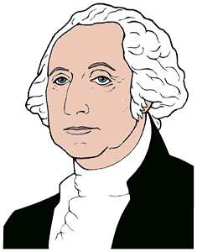 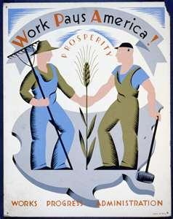

Holidays 假期 jià​qī​
Celebration (庆祝会 qìng​zhù​huì​)
New Year’s Eve (除夕 chú​xī​)
Fireworks (烟火 yān​huǒ)
African American (黑人 hēi​rén)​
Civil rights (公民权利 gōng​mín​quán​lì​)
Leader (领导 lǐng​dǎo​)
President (总统 zǒng​tǒng​)
Civil war (内战 nèi​zhàn
Slavery (奴隶制 nú​lì​zhì​)
Honors (尊重 zūn​zhòng​)
Die (死 sǐ​)
War (战争 zhàn​zhēng​)
Workers (工人 gōng​rén)
Harvest (收获 shōu​huò​).
Turkey (火鸡 huǒ​jī​)
Christian (基督徒 Jī​dū​tú)
Jesus (耶稣 Yē​sū​)
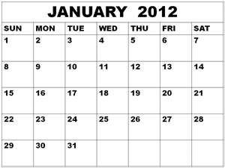

OTHER HOLIDAYS
International Women’s Day – March 8 (See separate presentation)

Arbor Day - March 12 (See separate presentation)

Mardi Gras – February or March: Big huge week-long wild (疯狂 fēng​kuáng​) party in the city of New Orleans 新奥尔晾.
Groundhog (土拨鼠 tǔ​bō​shǔ​) Day – February 2 - Folklore (传说 chuán​shuō​) holiday that may predict the beginning of Spring.
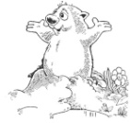
February 14 – Valentine’s Day – A day for boyfriends and girlfriends to give each other flowers, candy and other gifts.

March 17th Saint Patrick’s Day – People wear green clothing and drink green beer. It’s an Irish (爱尔兰 Ài​'ěr​lán​)​ American holiday.

April 1st April fools’ day – a day to play tricks on family, friends and co-workers.

Easter – Sunday following full moon between March 22nd and April 25th – this is a Christian holiday and people give candy and dye eggs different colors.

Earth Day – April 22nd Celebration of environmentalism 环保主义 huán​bǎo​zhǔ​yì​.

Mother’s Day – Second Sunday in May

Father’s Day – Third Sunday in June

August 26th Women’s Equality Day – Celebrates equal rights for women 男女平等 nán​nǚ​píng​děng​

September or October: Rosh Hashanah & Yom Kippur – Jewish (犹太 Yóu​tài​) Holidays
October 32st Halloween – People dress in costumes (行头 xíng​tou​; 装 zhuāng​), give candy and go to parties.

Hanukkah – December – Eight (8) day Jewish holiday

