(American) Breakfast Dialogue

Waitress: Good morning, what can I get for you?

Customer: I’d like two eggs over-easy with a medium-rare steak, hash browns, toast and coffee.

Waitress: Anything else I can get for you sir/ma’am?

Customer: Yes, a large glass of orange juice please.

Vocabulary 词汇 cí​huì​
- Style of cooked eggs:
Fried egg 煎蛋 jiān​dàn​
Sunny-side up 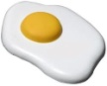
Over easy
Over hard
Scrambled egg 炒鸡蛋 chǎo​jī​dàn​
Soft-boiled egg 水煮蛋 shuǐ​zhǔ​dàn​
Boiled egg 煮蛋 zhǔ​dàn​
Poached egg 荷包蛋 hé​bāo​dàn​
Omelet 欧姆蛋 ōu​mǔ​dàn​
Steak 牛排 niú​pái​
Ham 火腿 huǒ​tuǐ​
Bacon 熏肉 xūn​ròu​ 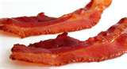
Toast 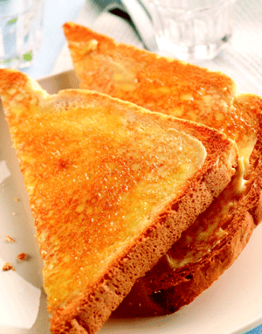
Hash brown potatoes 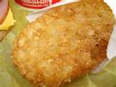 (Yeah, like at McDonalds)

EUROPEAN (欧洲 Ōu​zhōu​de) breakfast is different from American. Usually they have:
Croissants (牛角面包 niú​jiǎo​miàn​bāo)​ 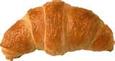
Crepe 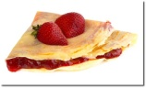
…and other breads, juice, and tea or coffee
(Sometimes they will have soft-boiled or poached eggs, but rarely will they have the “power-breakfast” Americans like.)

