Conjunctions连词

And和 Or还是 But但是 Because因为 If如果 So是以

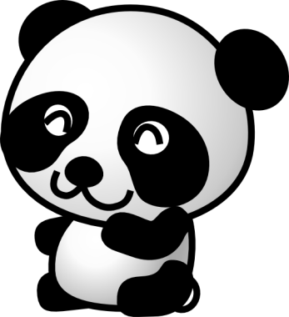or 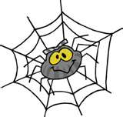

I like apples and bananas.

I like apples and bananas but not pineapples 菠萝.

I like apples because they are delicious 好吃.

If I eat apples, I am happy.

I like apples so I eat apples.

------------------------------
Pandas 熊猫, spiders 蜘蛛, dogs 狗, cats 猫,
chickens 鸡, snakes 蛇, cows 牛,
------------------------------

I like _______________ and ____________, but not ______

I like ____________ because they are ____________
funny 搞笑, cute 可爱

