Dialog 2 Literature文学
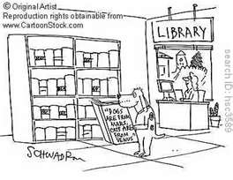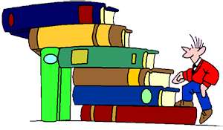
A: What are your hobbies 爱好?

B. I like to read literature文学.

A: Really? Like what?

B: My favorite Chinese literature includes (包括 bāo​kuò)​:

- Journey to the West, 西游记
- A dream of Red Mansions, 红楼梦
- Romance of Three Kingdoms 三国演义, and
- Outlaws of the Marsh! 水浒传

A: Do you like American literature too?

B: Yes, I especially like novels小说 (xiǎo​shuō)​ by Mark Twain.

A: Like what?

B: My favorite novel by Mark Twain is “Prince and the Pauper.”
(Prince 王子wáng​zǐ​ ; Pauper: 穷光蛋)
A: What’s it about?

B: It’s about a prince that trades places (交换 jiāo​huàn)​ with a pauper, the son of a beggar (乞丐 qǐ​gài​).

The Prince takes the paupers clothes (衣服 yī​fu)​ and goes out into the poor (穷人qióng​rén)​ city of London, while the pauper takes the Princes clothes and lives in the castle 城堡 chéng​bǎo​ with the king and queen. It’s an amazing 惊讶 jīng​yà​ story!

