Five Senses 感觉器官

I see看 with my eyes眼睛.
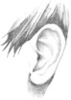 I hear听到 with my ears耳朵.
I smell闻到 with my nose鼻子.
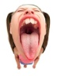I taste味儿 with my mouth口.
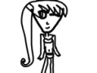I feel感觉 with my whole body身体. (Touch 触觉)
Flowers 花
Garbage 垃圾
Music 音乐
Fighting 搏杀
Food 饭
Crying 哭
Comfortable 舒服
Friends 朋友
My family 我家
Pizza 披萨
Silk 丝
Peaceful 平
Sad 悲
Socks短袜
Sick 病
Birds sing 鸟歌唱
Movies 电影
Money 钱
I like to see ______________.

I don’t like to see____________.

I like to hear _____________.

I don’t like to hear ___________.

I like to smell _____________.

I don’t like to smell ___________.

I like to taste _____________.

I don’t like to taste ___________.

I like to feel _______________.

I don’t like to feel ____________

