Arbor day 植树节 Zhí​shù​ Jié​

Arbor is Latin language (拉丁语 Lā​dīng​yǔ​) for “tree,” and it’s a worldwide holiday in which individuals (个人 gè​rén​) and groups (组 zǔ​) are encouraged
鼓励 gǔ​lì​ to go out and plant trees.

It started in the State of Nebraska in 1872 by Sterling Morton. It is estimated that about one million trees (1,000,000) were planted on that day.

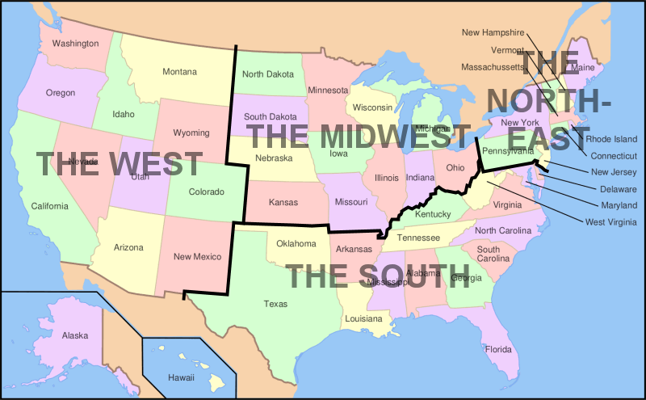

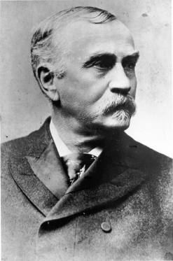
Sterling Morton

Every country has different Tree Planting Days.
China started celebrating this day in 1981.

Why are trees important?

For one thing trees produce oxygen 氧气 yǎng​qì​. A lot of oxygen.

About 20% of the air we breathe is oxygen. About half of the world’s oxygen comes from the oceans and half from trees.

This is one reason “deforestation” 砍伐森林 kǎn​fá​ sēn​lín​ is a very bad thing.

Thousands of trees are cut down every year in rainforests. 原始热带雨林 yuán​shǐ​rè​dài​yǔ​lín​ in South America and South Asia.

Would you pay 10 Yuan a month to help prevent deforestation?
I would (not) pay 10 yuan a month to prevent deforestation because ____________________.

Deforestation
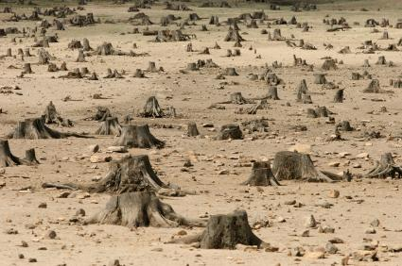
This is what happens when students lose their papers!

People have to cut rainforests down in Indonesia 印度尼西亚 Yìn​dù​ní​xī​yà​
and Brazil 巴西 Bā​xī​
to make for paper and the world becomes a desert 沙漠 shā​mò​

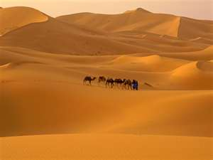
, and there will no oxygen 氧气 yǎng​qì for our children 子女 zǐ​nǚ​ and grandchildren!

Do you think in the future people will have to buy oxygen to stay alive?

Yes, I think in the future we will have to buy oxygen because ________.
- There are more and more people born every day?
- We keep cutting down forests?
OR
No, I don’t think people will have to buy oxygen.

Did you know that in the year 1800 there were only 1 billion people in the world (1,000,000,000)
, and now there are six billion (6,000,000,000)?

All those people are breathing and making CO2, using up the world’s limited oxygen while cutting down trees to make furniture 家具 jiā​jù​
and paper.
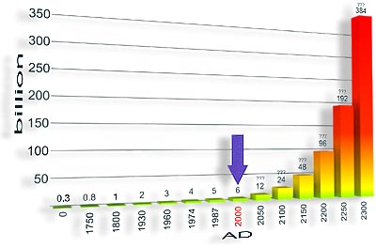

So, maybe tree planting day is important to remind us to conserve and protect 保护 bǎo​hù​ trees and not lose our papers in class!

Finally:

I think this discussion about trees is interesting.
OR
I think this discussion about trees is boring:

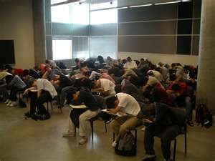

IELTS Speaking test question:
Describe a meaningful event in your life:
When I was six years old my father bought a sapling (baby tree) and put some water in a large bucket for planting a tree on a hill near our house. There were many other trees but he thought the hill needed one more. So, we took the sapling and water, climbed the hill, and dug a hole.
Then he put the sapling in the hole and covered the roots with earth. Then he poured water over it.

He explained the meaning of ecology 生态学 shēng​tài​xué​ to me, and the importance of trees. It was a very meaningful experience for me.

Is this a true story? It doesn’t matter to the IELTS examiner. They only rate your speaking based on pronunciation, fluency, grammar, and vocabulary.

Arbor day 植树节 Zhí​shù​ Jié​
individuals (个人 gè​rén​)
groups (组 zǔ​)
encouraged (鼓励 gǔ​lì)​
oxygen 氧气 yǎng​qì
deforestation” 砍伐森林 kǎn​fá​ sēn​lín
rainforests. 原始热带雨林 yuán​shǐ​rè​dài​yǔ​lín
desert 沙漠 shā​mò​
children 子女 zǐ​nǚ​
furniture 家具 jiā​jù​
protect 保护 bǎo​hù
ecology 生态学 shēng​tài​xué​

