Dialog 3 - Visiting Beijing (多久duō​jiǔ​ 北京)
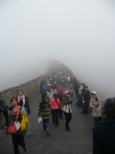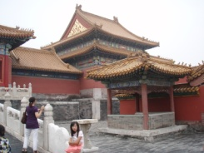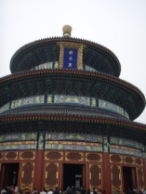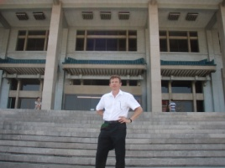
Q: How long (多久duō​jiǔ​) have you been here in Beijing?

A: Almost three years.

Q: Have you visited (参观cān​guān)​ many museums (博物馆 bó​wù​guǎn)​?

A: Definitely 实 shí ! I really like the National Museum. (中国国家博物馆)
It’s amazing. (了不起liǎo​bu​qǐ​)

Q: Have you been to any temples (寺 sì​) or the National Library 国家图书馆 guó​jiā​tú​shū​guǎn​?

A: Sure! (没错 méi​cuò​)! I visited the Temple of Heaven (天坛) Lama Temple (雍和宫 Yōng​hé​ Gōng​) and a few others too. And, of course (当然 dāng​rán​) I went to the National Library. It’s got a great collection (收集 shōují)​ of books.

Q: Have you visited the Great Wall (长城 Cháng​chéng​) and the Forbidden City
故宫 gù​gōng​?

A: Certainly! (当然 dāng​rán​) Many times!

Q: Did you try Beijing Duck北京烤鸭?

A: Oh! Absolutely! (断然 duàn​rán)​ It’s very delicious!

Q: What do you like best about Beijing?

A: I like all the different sports (运动 yùn​dòng​) facilities (设备shè​bèi​) here and of course the kind (心眼好 xīn​yǎn​hǎo​), friendly (友好 yǒu​hǎo​) people!

The “Don’t Say Yes or No” Game!

In the dialog today we learned some different ways to say “yes.”

Changing them to “no,” is easy! 简易 jiǎn​yì​
YES | NO
Of course 当然 dāng​rán​ | Of course not
Definitely 实 shí | Definitely not
Certainly 当然 dāng​rán​ | Certainly not
Absolutely 断然 duàn​rán​ | Absolutely not
Sure 没错 méi​cuò​ | Surely not

How to play the game:

One person asks 问 wèn​ another person some questions with ”Yes/No” answers 回答 huí​dá​.

But, the person answering cannot say “Yes” or “No.”

They have to use another word. As long as the person answering does not say “Yes” or “No,” he or she is winning 赢 yíng​!

