International Women’s Day 妇女节 Fù​nǚ​jié​
March 8, 2012
& Introduction to Feminism
女权主义 nǚquán zhǔyì
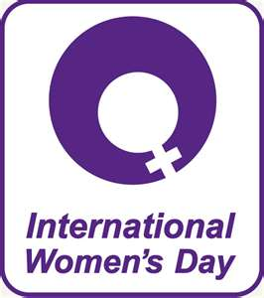
This is a general celebration of
- respect 尊重 zūn​zhòng​,
- appreciation 垂青 chuí​qīng​
- and love

… towards women and a celebration for women's
- economic 经济 jīng​jì​
- political 政治 zhèng​zhì​ and
- social 集体 jí​tǐ​
…achievements 成就 chéng​jiù​.

International Women’s Day started as a Socialist 社会主义制度 shè​huì​zhǔ​yì​zhì​dù​ political event, the holiday blended 混合 hùn​hé​ in the culture 文化 wén​huà​ of many countries
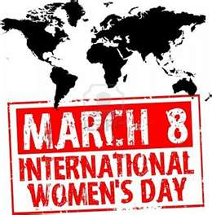
The first national 国民 guó​mín​ Women's Day was on 28 February 1909 in the United States following a declaration by the Socialist Party of America.

Then, German Socialist Luise Zietz started an annual (every year) 'International Woman's Day'
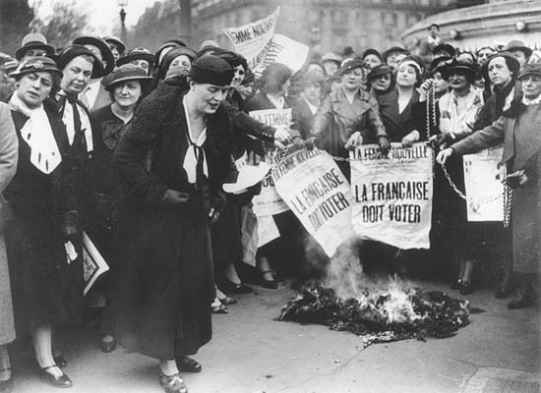
1975 was International Women’s Year, and the United Nations (联合国 Lián​hé​guó​) began sponsoring (赞助 zàn​zhù​) International Women's Day.
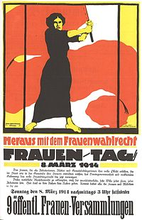
The UN theme 主题 zhǔ​tí​ for International Women’s Day 2012 is Empower 大用 dà​yòng​
Women – End Hunger and Poverty 贫困 pín​kùn​.
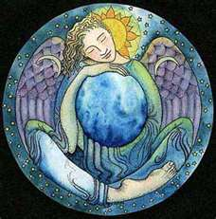

Feminism 女权主义 nǚquán zhǔyì is the belief that women are and should be treated equal (=) to men.
A Feminist is a person that believes in feminism.

In China
During the late Qing period 大清帝國, Dà Qīng Dìguó (1644–1911) and reform movements such as the Hundred Days' Reform, Chinese feminists called for women's liberation (自由 zì​yóu​) from traditional 传统 chuán​tǒng​ roles and Neo-Confucian (朱熹 Zhū​ Xī​) gender (性别 xìng​bié​) segregation.

Later, the Chinese Communist Party (中共 Zhōng​gòng​) created projects aimed at integrating (统一 tǒng​yī​) women into the workforce, and claimed that the revolution had successfully achieved women's liberation

In England
In Britain in 1918 the Representation of the People Act was passed granting the vote (投票 tóu​piào​) to women over the age of 30 who owned houses. In 1928 this was extended to all women over twenty-one
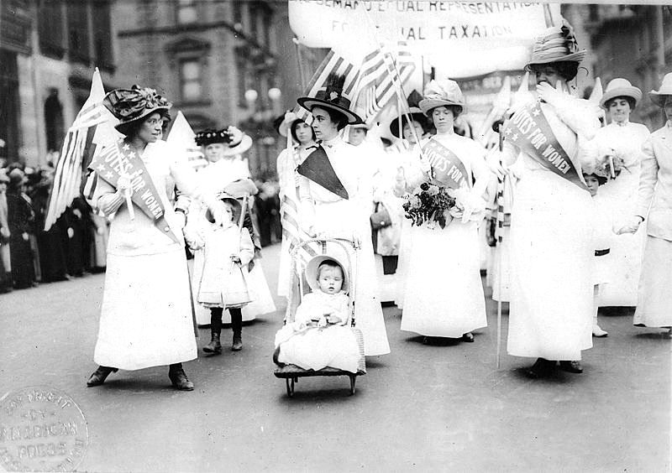
Feminist Suffrage Parade in New York City, 1912

In the United States, first-wave feminism is considered to have ended with the passage of the Nineteenth Amendment to the United States Constitution (1919), granting women the right to vote in all states.

Vocabulary
Women’s Day 妇女节 Fù​nǚ​jié​
Feminism 女权主义 nǚquán zhǔyì
Respect 尊重 zūn​zhòng​
Appreciation 垂青 chuí​qīng​
Economic 经济 jīng​jì​
Political 政治 zhèng​zhì​
Social 集体 jí​tǐ​
Achievements 成就 chéng​jiù
Socialist 社会主义制度 shè​huì​zhǔ​yì​zhì​dù
Blended 混合 hùn​hé
Culture 文化 wén​huà​
United Nations 联合国 Lián​hé​guó​
Theme 主题 zhǔ​tí​
Empower 大用 dà​yòng​
Poverty 贫困 pín​kùn
liberation 自由 zì​yóu​
traditional 传统 chuán​tǒng​
Neo-Confucian 朱熹 Zhū​ Xī​
gender 性别 xìng​bié​
Chinese Communist Party 中共 Zhōng​gòng​
integrating 统一 tǒng​yī​

