Nouns and Verb

Nouns名词 are people人, places地点 and things东西.

Nouns: Man男人, woman女, teacher老师, student学生, Beijing北京, pencil笔, table桌, Shanghai上海, school学校, book书, shoes鞋, computer电脑, Hu Jin Tao胡锦涛

Verbs are action 行为 words.

Verbs: Read看, talk说话, watch看, write写, eat吃, drink喝
In Chinese you can say: I happy. But, there is no verb! 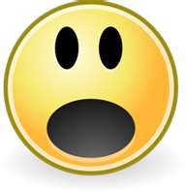

In an English sentence句子 you must要有 have a verb行

I am happy. (“Am” 是 is a verb行为)

Noun |  | Run
 |  | Hat
 |  | Think
 |  | Play
Verb |  | Hu Jin Tao
 |  | Hospital
 |  | Study
 |  | Book
An English sentence 句子 has a noun and a verb.

Pronoun Verb Noun
I like apples
You run to the store
He reads books

