Prepositions 介词
Prepositions show position = location 处, 位置 and relationships 关系.

I am going to the store. “To” is a preposition.
He came from home. “From” is a preposition.
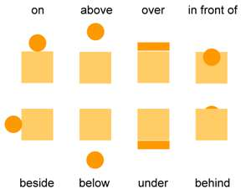

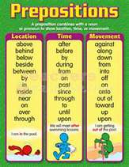
Tienjin is near Beijing.
There is no brain 脑 inside his head!
He worked all through 通过 the night.
Going through the tunnel隧道 it was dark.

于 yú​ (Chinese preposition) = in / at / to / from / by / than / out of
During = 中, 在这期间
During class, he always pays attention 关注, 注意.
From December to March it’s cold in Beijing.
The distance from Beijing to Shanghai is 10,75 kilometers.

Which are the prepositions?
After the test he’ll go to France for university until 2020.
For ten years he worked until he was rich.
Going toward school if wondered how well he would do on the test.

