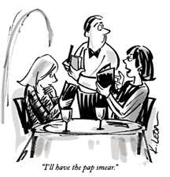
Restaurant - Ordering Dinner

Waiter/Waitress: Good evening sir/madam, welcome to Gregorio’s Famous Steak (牛排 niú​pái​) Restaurant. Here is the menu. (Five minutes later.) May I take your order please?

Customer 1: I’d like the steak and potato please.

Waiter/Waitress: How would you like your steak, rare 三分熟 sān​fēn​shú​, medium 五分熟, or well done 全熟 quán​shú​?

Customer 1: I’d like it well done, please.

Waiter/Waitress: And would you like mashed potatoes (土豆泥 tǔ​dòu)​ or baked 烘烤 hōng​kǎo​?

Customer 1: Baked please.

Waiter/Waitress: Would you like soup 汤 tāng​ or salad 沙拉 shā​lā​
for an entrée (kai wei cài)​?

Customer 1: I’d like a salad please.

Waitress: What kind of dressing (色拉酱 sè​lā​jiàng)​ would you like on your salad, Italian 意大利 Yì​dà​lì​, French, Blue Cheese 奶酪 nǎi​lào​, or Thousand Island 千岛酱 qiān​dǎo​jiàng​?

Customer 1: I’d like the Blue Cheese Dressing.

Waiter/Waitress: Ah, blue cheese! Good choice! And for dessert (甜点 tián​diǎn​), would you like ice cream, fruit, cheese cake (芝士蛋糕 zhī​shì​dàn​gāo​,) or pie 派 pài​?

Customer 1: Fruit sounds nice.

Waiter/Waitress: And you Sir/Madam, what would you like to order?

Customer 2: I’d also like the steak, medium rare please.

Waiter/Waitress: Very good. And, would you prefer soup or salad?

Customer 2: What kind of soups do you have?

Waiter/Waitress: We have cream of vegetable soup, and French Onion soup.

Customer 2: French Onion soup please.

Waiter/Waitress: And for dessert, would you like ice cream, fruit, cheese cake or pie?

Customer 2: Pie please.

Waiter/Waitress: Would you like blueberry, apple or pecan pie?

Customer 2: Apple pie please.

Waiter/Waitress: What would you like to drink?

Customer1: I’d like apple juice please.

Customer 2: I’d like milk.

Waiter: Very good. Your Entrée will be here shortly.

--------------------------------------------------------------------

Setting the table
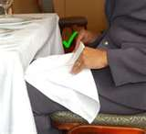
Salad fork 叉
Dinner fork
Dessert fork
Dinner knife 刀
Butter knife
Soup spoon 汤匙
Dessert spoon
Napkin 餐巾 As soon as you sit down to eat, the napkin goes in your lap.
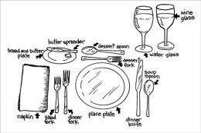
Note: If you want to practice this English in Beijing, go to “Outback Steak Ranch” (an American franchise steak restaurant) located by Workers Stadium in Sanlitun, and WangFuJing). ONLY SPEAK ENGLISH!

