Triathlon 三项全能
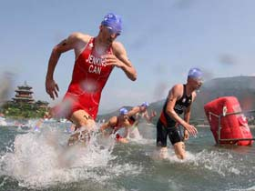
http://beijing.triathlon.org/
Venue Video: http://beijing.triathlon.org/event_info/venue/

Triathlon History 历史

The first triathlon took place in San Diego, California on September 24, 1974.

The race, which took place in San Diego’s Mission Bay, had a 5.3-mile run, followed by a 5-mile bike and a 600-yard swim in the Bay. A total of 46 athletes 运动员 finished the race.
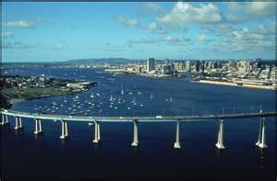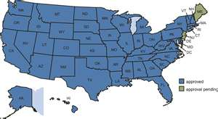
EFL QUESTIONS
How far is one mile 哩?
le (unit of length equal to 1,609.344 m)
5 miles = 8.045 Km

How long is one yard?
91.44 CM
How far is 600 yards?
.55 KM
&&&&&&&&&&&&&&&&&&&&&&&&
Triathlon was awarded full Olympic Games medal status by the IOC at its Congress in Paris in 1994.

Triathlon made its Olympic debut at the 2000 Sydney Games.

BEIJING TRIATHLON
An Olympic-distance triathlon combines a 1.5 km swim, a 40 km bike ride and a 10 km run. Every triathlon includes two transitions (swim to bike and bike to run). Elite athletes typically make these transitions in less than 30 seconds.

Average finishing times at World Championship and World Cup races are around 1 hour and 50 minutes for the Elite Men and around 2 hours for the Elite Women.

MONEY!

A total of $1.8 million USD will be available for athletes racing the Dextro Energy Triathlon ITU World Championship Series.

Gold $55,000
Silver $42,000
Bronze $30,000
4th $20,000
5th $16,000
6th $12,000
7th $10,000
8th $8,000
9th $7,500
10th $7,000
11th $6,500
12th $6,000
13th 5,500
14th $5,000
15th $4,500
16th $4,000
17th $3,500
18th $3,000
19th $2,500
20th $2,000

DISCUSSION QUESTIONS

Would you like to compete 竞争 (jìng​zhēng)​ in a Triathlon someday 日后 rì​hòu​?

Would you like to watch the Changping Triathlon?

I think Triathlons are:

…fascinating, 有趣

…a little interesting 一点点 有意思

…boring 无聊 wú​liáo​

Can you get money competing in Triathlons?
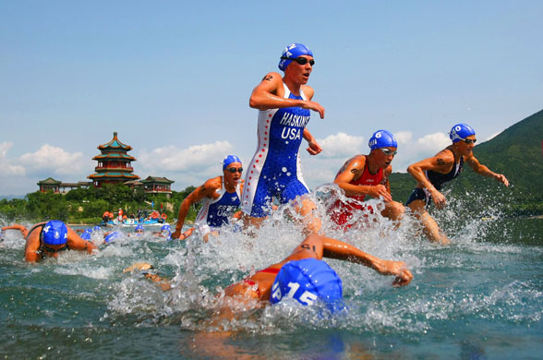

http://wcs.triathlon.org/

Venue Video: http://beijing.triathlon.org/event_info/venue/

Day to day schedule & leaders to watch for
http://www.triathlon.org/news/article/overall_beijing_preview_what_to_watch_out_for_and_why/

Photo galleries
http://wcs.triathlon.org/multimedia/photos/

