US Embassy Visa Interview Questions
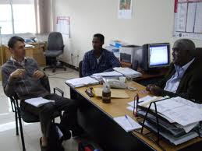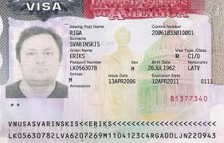
http://www.immihelp.com/visas/studentvisa/interview-tips.html
Why the specified University?
How many Universities have you applied?(both admits and rejects)
Which university accepted you?
Who is sponsoring you?
What is your father’s income?
Do you have any brothers or sisters?
09. | Do you have any relatives in USA?
10. | What will you do after completing MS? /plans after Graduation?
11. | Show your experience certificate?
12. | Why study in USA?
13. | Did you get any scholarship?
14. | Why haven’t you got any scholarship?
15. | Have you got any loans?
16. | Show your Pass Book/Bank Statement?
17. | What is your Undergraduate GPA/Percentage?
18. | Parent’s retired. Then how will they pay?
19. | Tell about your University?
20. | Mention some professor’s names?
21. | Tell me how you can prove that you are going to come back to your home country?
22. | Where did you brother/parents complete their studies?
23. | Why are you leaving your current job?(if you are working)
24. | Have you ever been to US?
25. | What will you do after coming back?
26. | Where do your parents live?
27. | Do you know anyone (in USA) in your University?
28. | What will you do if your visa is rejected?
29. | Will you come home during summer?
30. | Why do you think the University is giving you a scholarship?
31. | Why do you wish to study in the USA and not in India?
32. | If you have changed your field of specialization (for e.g. if you are BE Mechanical and opting for MS in Computer Science) then what brought about the change?
33. | What steps have you taken to ensure that you will be able to perform well in the new field you wish to change to?
34. | What do you plan to study at the University?
35. | How will you finance your education for 2 years or 3 years?(generally you have to prove that you have sufficient funds for the first year education but I suggest you be prepared with the answer)
36. | Do you have a brother/sister or any other relative already at this University?
37. | Tell me about yourself?
38. | What are your hobbies?
39. | What does success mean to you?
40. | Where do you plan to be in 5 years from now?
41. | Tell about your achievements?
42. | What are your strengths?
43. | What are your weaknesses?
44. | How did you prepare for this interview?
45. | Describe your dream career?
46. | What are your career goals?
47. | What are you looking for in life?
48. | What are your grades like?
49. | What was your Bachelors degree in?
50. | Why this University and not other Universities?
51. | Why do you plan to do MS?
52. | Your passbook shows that a large amount of money has recently been deposited?
53. | Why are your GRE/TOEFL scores low?
54. | Why are you changing your stream?
55. | What are your plans after graduation?
56. | You look like a potential immigrant or I don’t think you will come back?
57. | What do you know about US education?
58. | Why are you applying for Fall only?
59. | What do you want to study in US?
60. | What is your Major?
61. | What is the purpose of your trip?
62. | How will you support your education?
63. | Who is sponsoring you?
64. | Why do you want to do MS/MBA?
65. | Why did you select this University?
66. | Do you have any relatives in the US?
67. | Why is your GRE/GMAT/SAT/TOEFL score low?
68. | What are you plans after completing your studies?
69. | What is your father’s annual income?

